

**SEND BRIEFING PARENT WEBINAR**

*April 2021*



Parent/Carer Webinars take place regularly throughout the year and cover a number of different topics. Please see the local offer website for further details. Each webinar should last approximately one hour and take the format of a presentation followed by an opportunity to ask questions.

**Occupational Therapy - Fine Motor Moves**

**Helping your child to do the SMALL things – Junior school and Secondary school age children**

**Speakers: Ellie Steer & Janet Tighe- Occupational Therapists**

**Tuesday 27th April-** **10.00am – 11.00am**

**Ticket Link:**

[https://www.eventbrite.co.uk/e/fine-motor-moves-helping-your-child-do-the-small-things-tickets-144623852837](https://eur01.safelinks.protection.outlook.com/?url=https%3A%2F%2Fwww.eventbrite.co.uk%2Fe%2Ffine-motor-moves-helping-your-child-do-the-small-things-tickets-144623852837&data=04%7C01%7CGillian.Leach%40birmingham.gov.uk%7C6183d2e2778f4891260708d8dfc55d37%7C699ace67d2e44bcdb303d2bbe2b9bbf1%7C0%7C0%7C637505386043169003%7CUnknown%7CTWFpbGZsb3d8eyJWIjoiMC4wLjAwMDAiLCJQIjoiV2luMzIiLCJBTiI6Ik1haWwiLCJXVCI6Mn0%3D%7C1000&sdata=rGe%2BTpm2YzD7waXccvS8G%2FTxjq8rwoSnrr%2BBl8gj1X4%3D&reserved=0)

**Helping your child to do the SMALL things – Early Years and Infant school age children**

**Speakers: Katie Green & Sarah Gallagher- Occupational Therapists**

**Wednesday 28th April –** **1.00pm – 2.00pm**

**Ticket Link:**

[https://www.eventbrite.co.uk/e/fine-motor-moves-helping-your-child-do-the-small-things-tickets-144624312211](https://eur01.safelinks.protection.outlook.com/?url=https%3A%2F%2Fwww.eventbrite.co.uk%2Fe%2Ffine-motor-moves-helping-your-child-do-the-small-things-tickets-144624312211&data=04%7C01%7CGillian.Leach%40birmingham.gov.uk%7C6183d2e2778f4891260708d8dfc55d37%7C699ace67d2e44bcdb303d2bbe2b9bbf1%7C0%7C0%7C637505386043169003%7CUnknown%7CTWFpbGZsb3d8eyJWIjoiMC4wLjAwMDAiLCJQIjoiV2luMzIiLCJBTiI6Ik1haWwiLCJXVCI6Mn0%3D%7C1000&sdata=4bvlpA01PpDmm7x4gocF83v2S06bTtZkNHv71qIQ5nE%3D&reserved=0)

* To develop an understanding of why children display challenging behaviour or struggle to manage their emotions
* To have practical strategies to take away to support your child at home

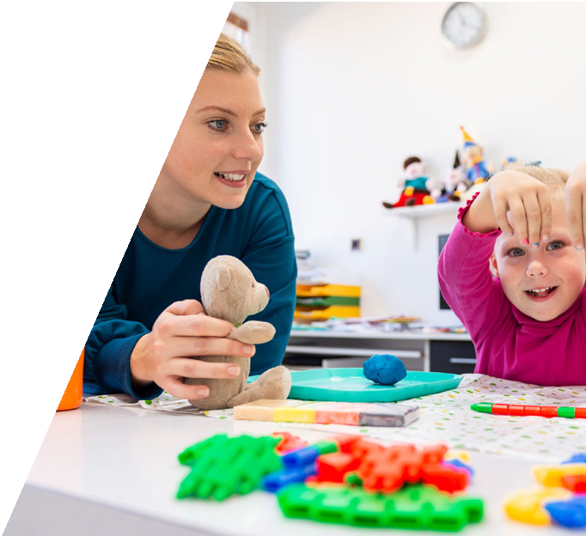

All people who book a ticket will be sent a copy of the presentation and a copy of the recording of the Webinar.